Project Name |  | Confidentiality Level
Database Management System |  | Public
Project ID | Version | Document Code
BP | 1.0 | BP

RKDBMS Software System Design Specification



Copyright © Ruankosoft Technologies(Shenzhen), Co., Ltd.
. All Rights Reserved
Revision Record
Date | Revision Version | CR ID /Defect ID | Sec No. | Change Description | Author
03.05.2017 | 1.0 | 15309004 |  |  | Park Jisu

Content
1 Introduction 5
1.1 Purpose 5
1.2 Scope 5
1.2.1 Name 5
1.2.2 Functions 5
1.2.3 Applications 5
2 Level 0 Design Description 5
2.1 Software System Context Definition 5
2.2 Design Considerations 6
2.2.1 Design Alternatives 6
2.2.2 Design Constraints 7
2.2.3 Other Design Considerations 7
3 Level 1 Design Description 7
3.1 System Architecture 7
3.1.1 Description of the Architecture 8
3.2 Decomposition Description 9
3.2.1 Database Management 9
3.2.2 Module/Subsystem 2 Description 10
3.3 Dependency Description 10
4 Level 2 Design Description (Optional) 11
4.1 Create Database 11
4.2 Module Name 2 12
4.3 Add Field 13
5 Data Structure/Database Design 14
6 UI Design 15
7 Detailed Design of Module 15
7.1 DataStructure.h 15
7.1.1 Overview 15
7.1.2 Definition 15
7.1.3 Attributes 15
7.1.4 Methods 15
7.2 Class2 Design 16

Keywords:
DBMS RDBMS MFC SDI Dialog C/S MVC Integrity Database Table Filed Record

Abstract:
This system is the first version of the database management system, including database creation, database table management, record addition and query, integrity constraint implementation, index creation and implementation, multi-user, concurrency processing, transaction processing, database backup and recovery, etc. This document describes the design of each function module to help the software developers analyze and design the software better. At the same time, it helps the clients to give better suggestions.

List of abbreviations:
Abbreviations | Full spelling | Chinese explanation
SDI | Single Document Interface | 单文档界面
MFC | Microsoft Foundation Classes | 微软基础类库
DBMS | Database Management System | 数据库管理系统
RDBMS | Relational Database Management System | 关系型数据库管理系统
C/S | Client/Server | 客户/服务器模式
MVC | Model View Controller | 模型-视图-控制器

- Introduction

Purpose
This document describes the Database Management System’s design process, including general design and detailed design, in order to conduct project team to implement coding and unit testing. Expected reader of this specification is intermediate user (refers to project team member, client representative, testing staff, QA and etc.)

Scope
    - Name
Database Management System
    - Functions
Software functions please refer to the requirements specification document: requirement analysis of Database Management System.
    - Applications
Not available.

- Level 0 Design Description

Software System Context Definition
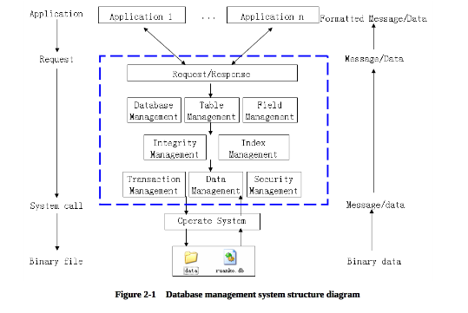
The architecture of the database management system includes: DBMS architecture, user interface, syntax analysis, query processing, directory management, concurrency control, recovery mechanism, physical storage management, etc. This system mainly implements the basic functions of query processing, directory management, concurrency control, and recovery mechanism. The physical storage management directly utilizes the file management function of the operating system. The syntax analysis and user interface will not be implemented temporarily.

This system is a desktop application with window interface. The architecture is C/S structure. Many servers can be created on the whole network. Each server is responsible for its own data storage. Through the network, the client can connect to any one or many servers. A server can provide service for many clients. The system architecture diagram is as follows:

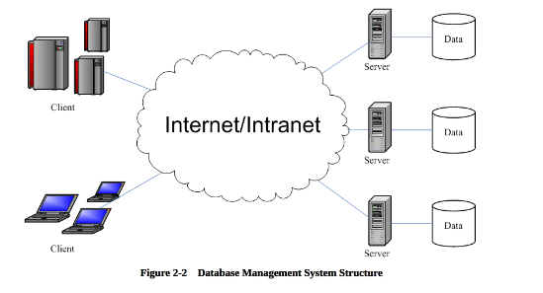

Design Considerations
    - Design Alternatives
- Program structure design
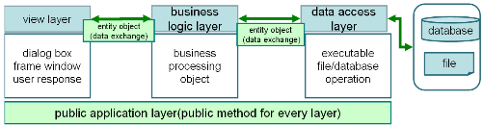

Based on the logic responsibility, the program software structure can be divided into 3 layers: presentation layer, business logic layer and data access layer. Data in each layer is transferred by “entity class” (data objet). Besides, public class that irrelative with business may be used in layers in the program as the “Tool class.”

2. Data Storage Structure
The system stores data with the binary file of the operating system, and saves the definition data and data information with the folder and file. DBMS system definition files include the database description file (ruanko.db), table description file (*.tb), table definition file (saves field information, *.tdf), index description file (*.tid), integrity description file (*.tic). The data files of DBMS include the record file (*.trd), index data file (*.ix), log file (*.log), transaction data file (*.tac), temporary file (*.tmp), etc.
The relation diagram between the database description file, table description file, table definition file and record file is as follows:
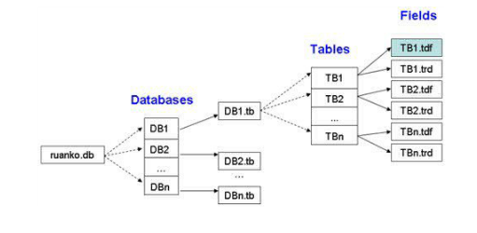
    - Design Constraints
      - Standards compliance
Could expand the specifications that do not exist in the following requirements, but it cannot contrary to the standard. It follows :< COE technical requirement standard of Ruanko Lab>, <COE programming standard requirement of Ruanko Lab>.
      - Hardware Limitations
The minimum configuration of the hardware:
CPU: 1GHZ
RAM: 128MB
To ensure that the game can run smoothly, the configuration best meet the following requirements:
CPU: 1.8GHZ
RAM: 1G
      - Technology Limitations
Parallel operation: Allow multiple games running at the same time, and can ensure the correctness and completeness of the data.
Coding standard: COE programming standard requirement of Ruanko Lab

    - Other Design Considerations
Not available.

- Level 1 Design Description

System Architecture
    - Description of the Architecture
The system is developed according to the thought of “divide and rule”. The functions are divided into many modules to manage and develop individually. The detailed module division of the system is shown below:
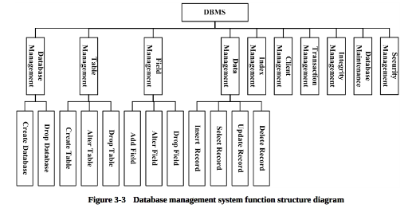
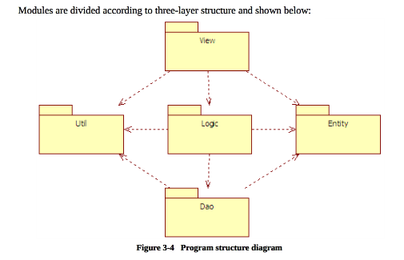

- Project Structure

This system is divided into two main parts of the database server project and database enterprise manager. The client is a SDI project. The server is a dialog project.
The project name of the client is RKDBMS.
The project structure is shown below:
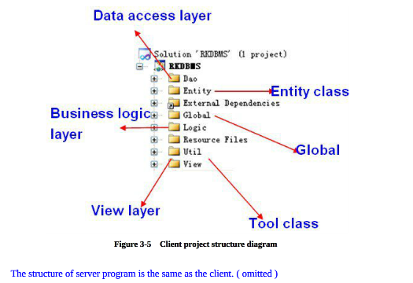

- Project program structure
Make logic to program by by VS2010 and VS2017 Solution Explorer through Filter
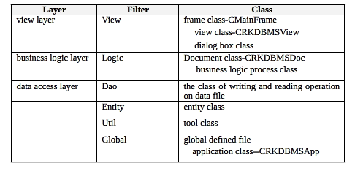

Decomposition Description
This section describes the packages, sub-systems, modules in the system.
    - Database Management
- Overview
Create and delete the database. Implement database definition file creation, modification and query.
- Functions
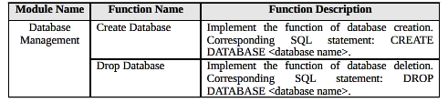
    - Module/Subsystem 2 Description
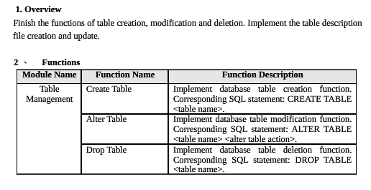

Dependency Description
This project is a windows window and depends on the operating system. The data storage depends on the file management system of the operating system, the communication between the server and client depends on TCP/IP network communication protocol.

- Level 2 Design Description (Optional)

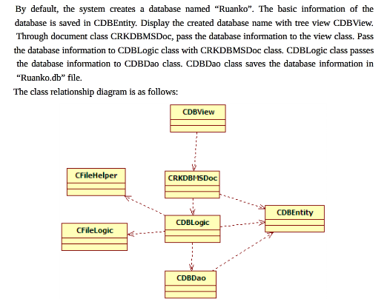
Create Database

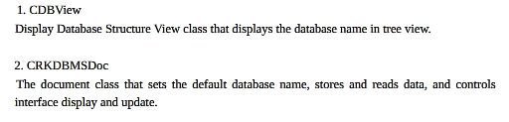
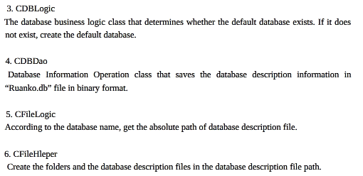

Module Name 2
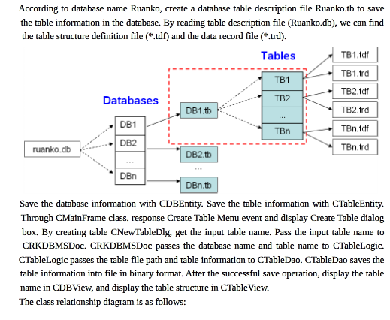
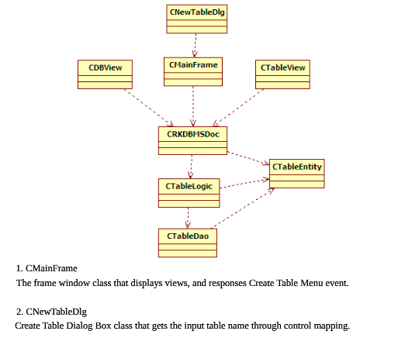

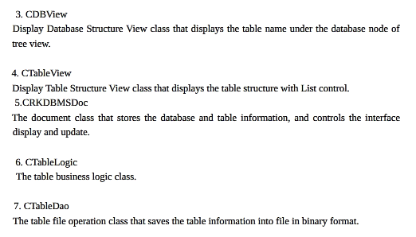

Add Field
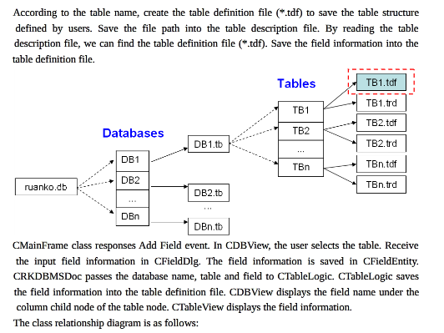
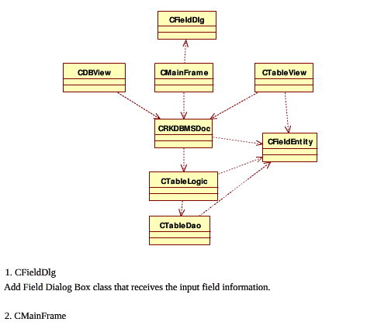
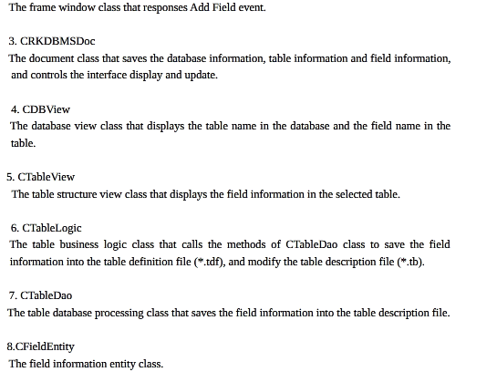

- Data Structure/Database Design
Basic Data Type
INTERGER | Description | Size | Progress Type
INTEGER | Integer | 4 bytes | int
BOOL | Boolean type | 1 byte | bool
DOUBLE | Floating point number | 2 bytes | double
VARCHAR | String type, maximum length is 255, ended with “\0” to mark the end of a string. | 256 bytes | Char[n]
DATETIME | Date time type | 16 bytes | SYSTEMTIME
File design
Type | File | Name | Remark
Data definition file | Database description file | ruanko.db | Save the database information
 | Table description | *.tb | Save the table information
 | Table definition file | *.tdf | Save the field information
 | Integrity description file | *.tic | Save the integrity constraints
 | Index description file | *.tid | Save the definition of the index
Data File | Record File | *.trd
 | Index data file | *.ix
 | Log file | *.log

- UI Design
Main Interface
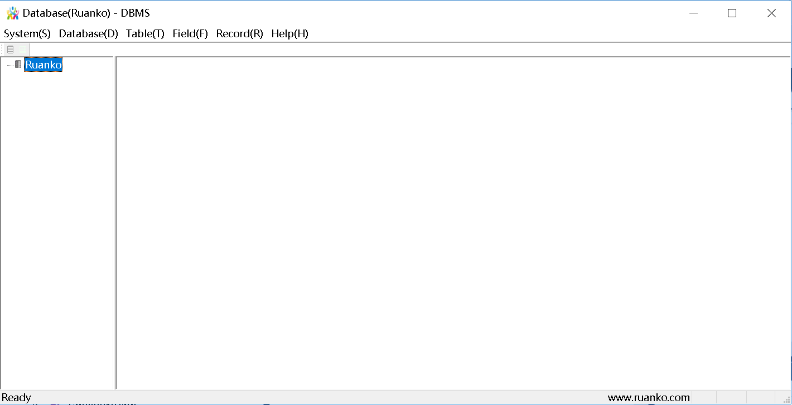
Show Table Interface
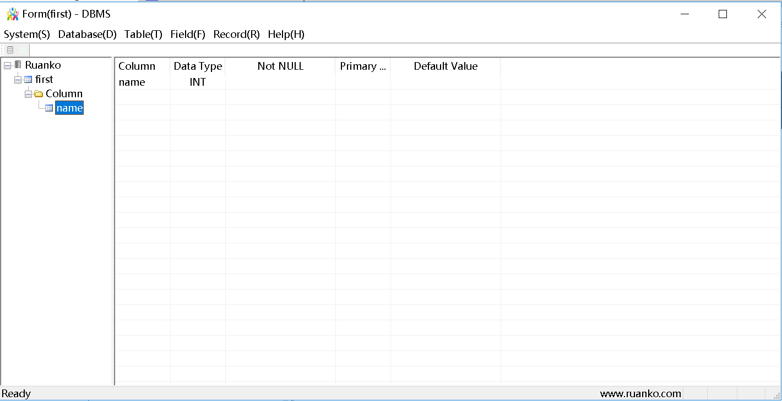
Create Table Interface
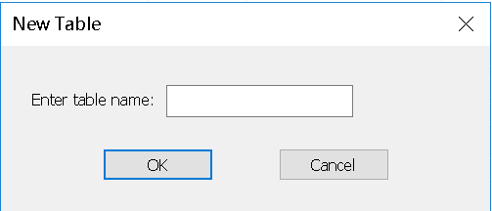
Add Field Interface
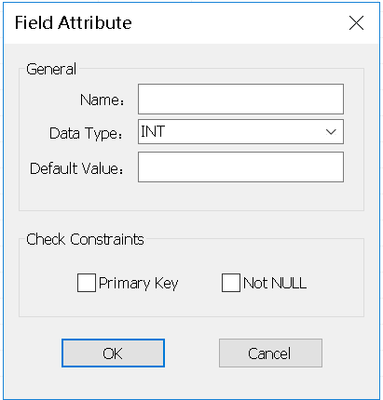

Insert Record Interface
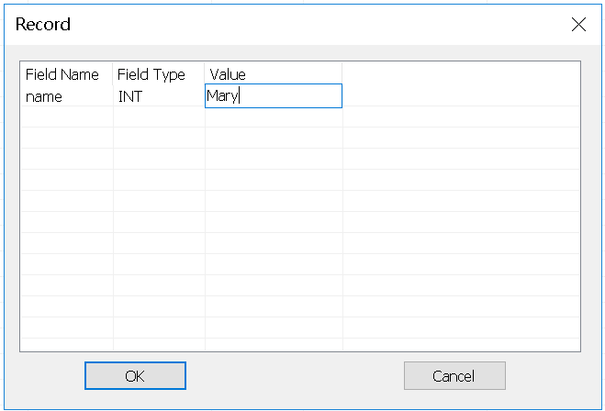

- Detailed Design of Module

DataStructure.h
    - Overview
Database information block
    - Definition
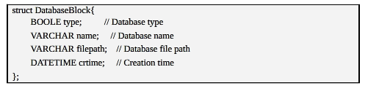.
    - Attributes
The common data structure should be described here.
Visibility | Name | Type | Brief descriptions
    - Methods
Every method should be described.
      - Method1
(1) Method Descriptions
Prototype
Description
Calls
Called By
Input
Output
Return
Exception

(2) Implementation Descriptions
Pseudo codes could be used to depict the method definitions. This is the most important part of LLD.
      - Method2

Class2 Design

